Administrator

Informations registration

Login process

Username and Password verification

Customers information registration and Account creation

View and manage printed transactions slips

All Feedback details

Transactions available details

View and manage feedback

Transaction registered details

Transactions making

Customer and Account details

Administrator

Available informations

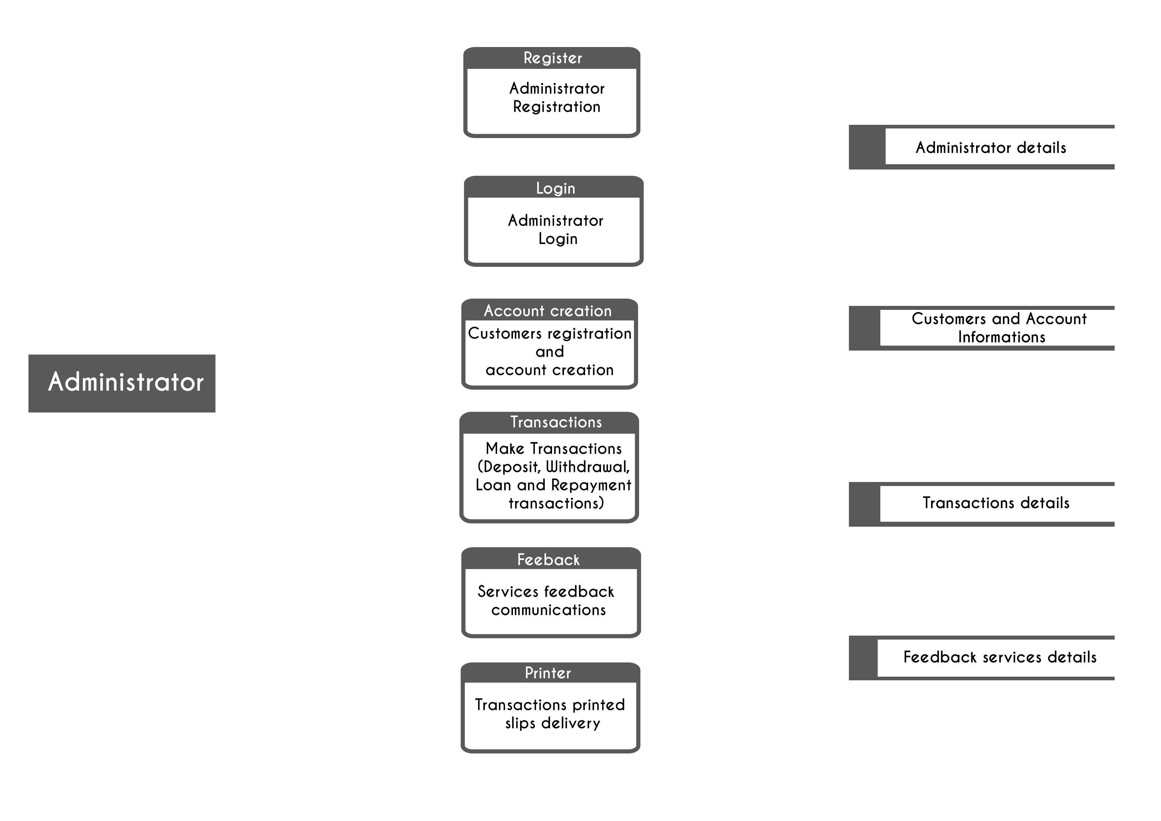

Available transaction details

Checked available feedback

Services Feedback sender

Printed transaction slips delivery

Transaction available details

Transaction request

Customer and Account provided details

Provide customer informations

